**Check if all managed servers are in a backup schedule**

1. Sign into Azure portal and go to virtual machines

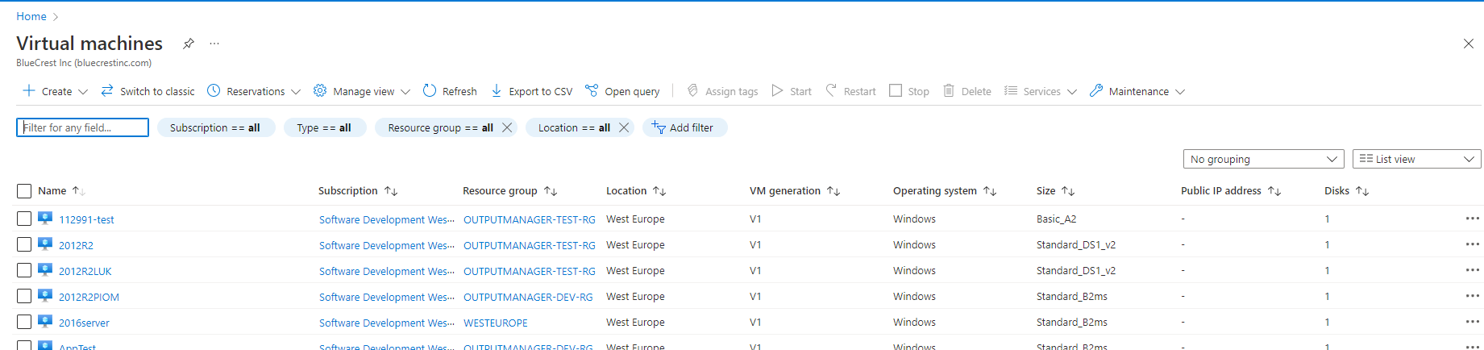

Check if server is managed by atos by filtering out with backup policy

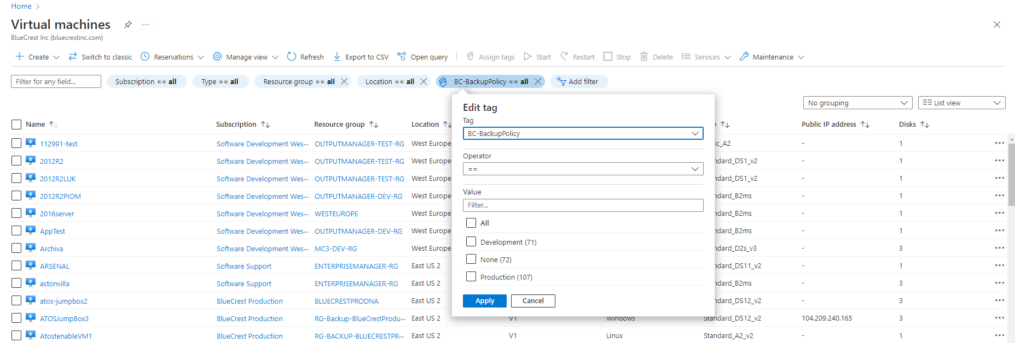

Go to server and check if backup is enabled

